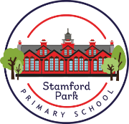
Year 4 - Home Learning
Spring 1

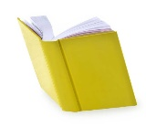
Reading
Children will get the opportunity to visit the library to choose a book to read. Please encourage your child to read a little each day. We have also uploaded some separate English tasks for you to have a go at.
Mathematics
MyMaths homework will continue be set, with weekly tasks linked to current topics. As usual, there will be a weekly start and end date for each task set meaning a shorter window of completion.
English - Autobiography/Biography  You can choose to:  - Interview a family member/close friend and write a biography about their life.  - Talk to your family, look at photos/diaries and your school books to create an autobiography about yourself. | 
Science – Electricity  Make a list of as many electrical items you can find in your home as you can.  Think about your usual day to day routine and record all the different ways you use electricity. | 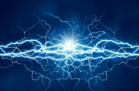
Geography  Research, and map, where five different foods have come from in  your home. | 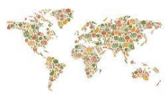
Health and Wellbeing  Think of an affirmation or mantra of positivity for you, and your class.  Design a poster about it to be displayed in school, or at home (see below for ideas). | 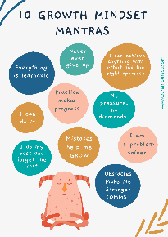
PE  Invent a game which you can play with your friends at playtime.  Remember to make your games as inclusive as possible to allow as many people to join in as possible.  It should have a positive impact! | 

