
Year 3 Home Learning
Reading

Each week, the children will get the opportunity to visit the library/class library to choose a book to read.
Your child may receive an additional reading book at the appropriate ability level.
Please encourage your child to read daily.

English
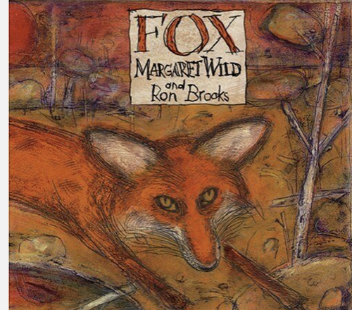
is their favourite one.
- Lesson 10 - Children write a subtitle ‘My least favourite chapter’. Children then give reasons why their chosen chapter is their least favourite one.

During our English lessons we will be reading ‘Fox’ by Margret Wild.
Which are your favourite animal stories and why?
Why do you think some authors use animals in their stories instead of humans?
What do you like about the illustrations in this story and why?

Useful websites for English writing-
https://www.bbc.co.uk/bitesize/primary
https://www.topmarks.co.uk/english-games/7-11-years/spelling-and-grammar
https://www.thenational.academy/teachers/key-stages/ks2/subjects

Mathematics

‘MyMaths’ homework will be set with weekly tasks linked to what has been taught in class.
Please also remember to log into ‘Times Table Rock Stars’ and practise each set of multiplication facts regularly.

Science – Forces and Magnets
See if you have a magnet at home (sometimes they are used to attach things to fridges). If you do have one try creating a magnetic fishing game using your magnet.
Tie the magnet using a piece of string to a stick to create your magnetic fishing rod. Then spread out some magnetic items around the floor and try picking them up using your magnetic fishing rod.

If you do not have a magnet at home, can you design a game similar to the magnetic fishing game which we can test out in school. Bring in a design and plan with rules on how to play your magnetic game and we will test some out over the half term during Science lessons.

History - Would you prefer to have lived in the Stone Age, Bronze Age or Iron Age?

What can you find out about humans who lived in ‘The Stone Age’?
Where did they live?
Produce a short non-fiction book about ‘The Stone Age’?
Remember to include features such as, a contents page, a glossary and an index.

Art - Charcoal Drawings
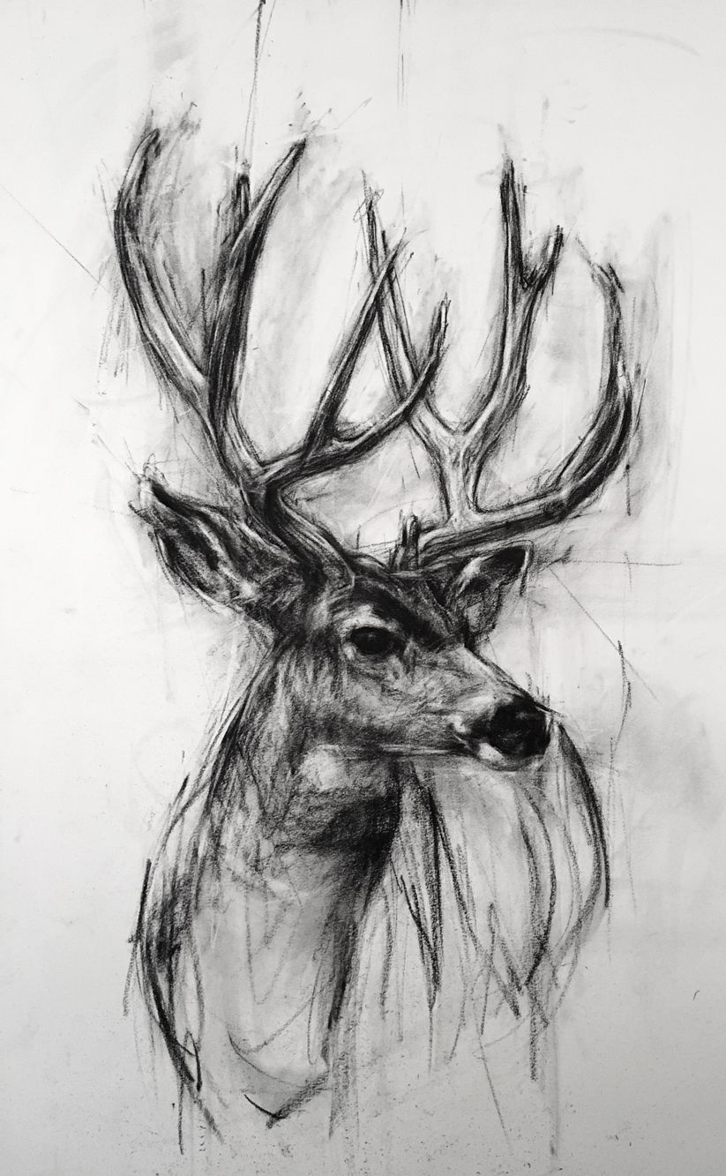
Draw a charcoal picture of a living thing at home.
This could be a plant, a pet or a person.
Can you use the charcoal to show shade and darker areas on your drawing?
Computing – Email
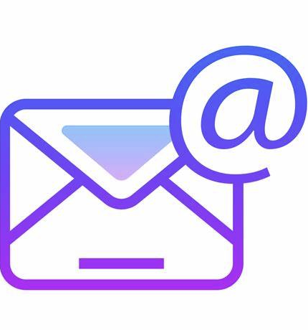
Compose an email with the help of an adult.
Can you think of at least five things you love about coming to Stamford Park Primary School?
Maybe you could mention your favourite lessons, trips or friends?
Please send this to the class email address.

Creative Writing

