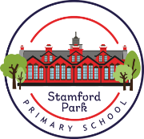
Year 3 Home Learning
Reading
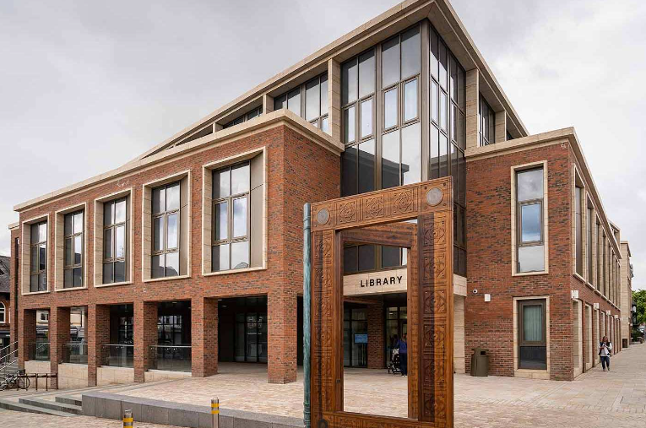
Each week, the children will get the opportunity to visit the library/class library to choose a book to read.
Your child may receive an additional reading book at the appropriate ability level.
Please encourage your child to read daily.

English
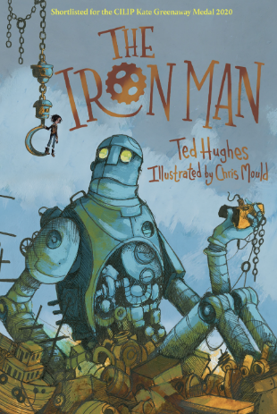
is their favourite one.
- Lesson 10 - Children write a subtitle ‘My least favourite chapter’. Children then give reasons why their chosen chapter is their least favourite one.

During our English lessons we will be reading ‘The Iron Man’ by Ted Hughes.
Think of other stories with similarities to this one.
Discuss your favourite part of the book with an adult and give reasons.
Where is this story set?
Mathematics

‘MyMaths’ homework will be set with weekly tasks linked to what has been taught in class.
Please also remember to log into ‘Times Table Rock Stars’ and practise each set of multiplication facts regularly.
Science – Forces and Magnets
What is a force?
Make a poster featuring as many different types of forces as you can think of.
Take some photographs of some forces in action.
Make a presentation using your images.

Geography – Why do people live near volcanoes?
Can you find the locations of some towns or cities that are near to a volcano?
Why do you think they are built near to volcanoes?
Draw a map showing where these cities are.

French

Please remind yourselves of the French that you learnt in Year 2. If you can, create a poster with some of the vocabulary that you already know for a display in our classroom.

RSE - PSHE
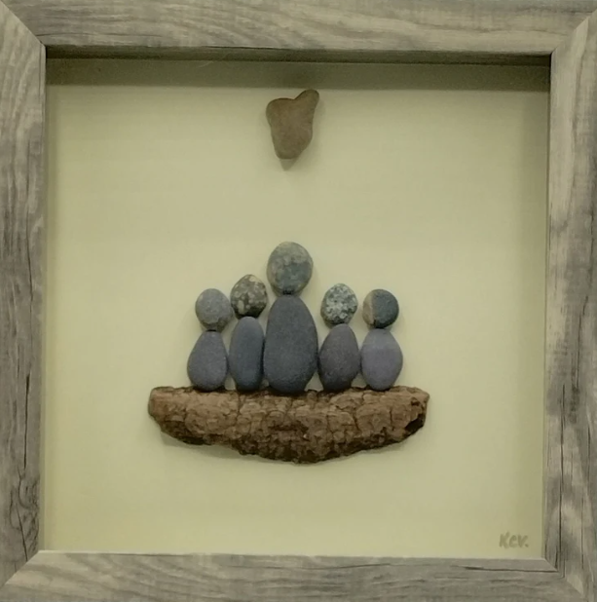
Which people in your life are special to you?
What makes them important people in your life?
Write a letter to a special person telling them why they are so fantastic.

