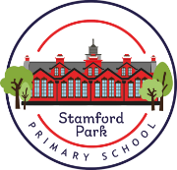
Year 3 Home Learning
Reading
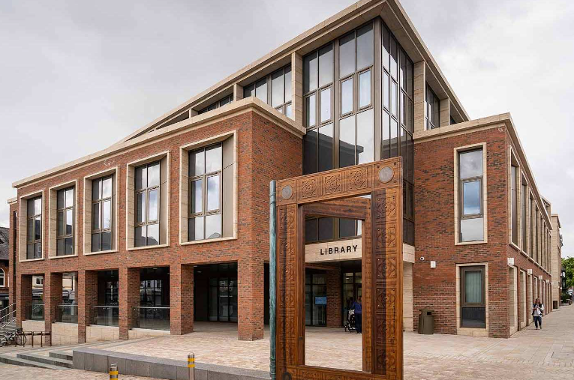
Each week, the children will get the opportunity to visit the library/class library to choose a book to read.
Your child may receive an additional reading book at the appropriate ability level.
Please encourage your child to read daily.

English
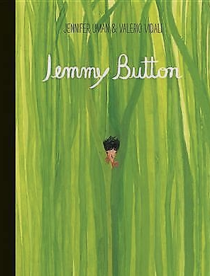
is their favourite one.
- Lesson 10 - Children write a subtitle ‘My least favourite chapter’. Children then give reasons why their chosen chapter is their least favourite one.

During our English lessons we will be reading the story of ‘Jemmy Button’ by Jennifer Uman and Valerio Vidali.
Write a character description of Jemmy Button.
Remember to talk about the appearance of Jemmy Button, his character and any other information about him.

Mathematics

‘MyMaths’ homework will be set with weekly tasks linked to what has been taught in class.
Please also remember to log into ‘Times Table Rock Stars’ and practise each set of multiplication facts regularly.

Science – Plants
Can you research different plants and the environment that suits them?
Maybe you could visit a garden centre to look at the large variety of plants and the environment that they like.
What kind of plants can survive indoors?
If you could have a plant in your bedroom, what kind of plant would you have and why?
History – Why did the Romans settle in Britain?
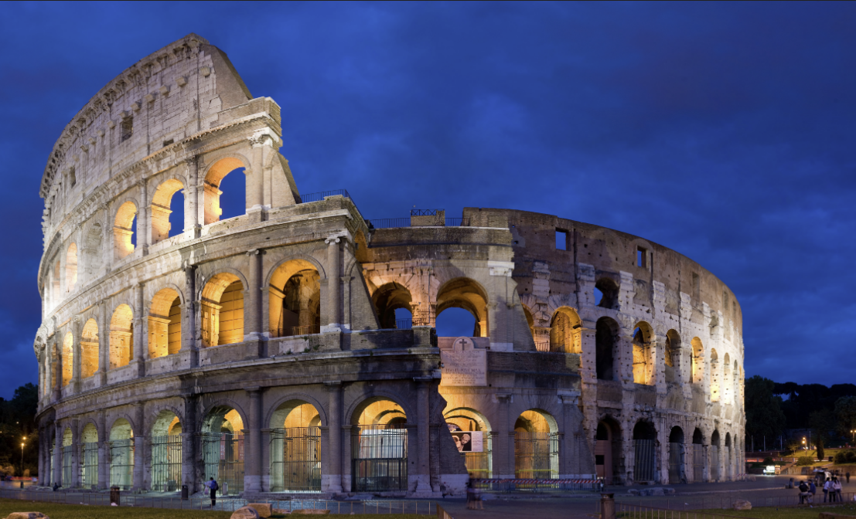
Who were the Romans?
Where did they originate?
How did they impact our life here in Britain?
Produce a fact file about The Romans.
RSE – PSHE

What are rules for?
How do they protect people?
Write a list of ten rules covering how you think people should treat one another.
Could people follow them in school?
Spring 2 – The Romans

