
Year 4 - Home Learning
Summer 2

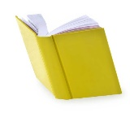
Reading
Children will get the opportunity to visit the library to choose a book to read. Please encourage your child to read a little each day.
Mathematics
MyMaths homework will continue be set, with weekly tasks linked to current topics. As usual, there will be a weekly start and end date for each task set meaning a shorter window of completion.
Also, please ensure that your child is practising their multiplication facts, (times tables) one to twelve, using Times Tables Rock Stars.
English – The Journey  Our new focus text which we will be using this half term is ‘The Journey’ by Francesca Sanna.  - This story is about a family making a move to an unknown place.  Have you ever had to move or visit somewhere new?  What were your feelings?  Write a diary entry telling the story of your journey and how yiu felt about it at the time.  - Where would you like to go and visit that is new to you?  Write a persuasive document reasoning why you would like to go and visit there. | 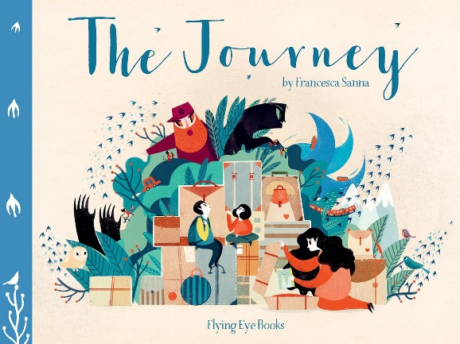
Science – Famous Scientists and Inventors  What makes a scientist famous?  What exactly is an invention?  Who is your favourite scientist and did they invent anything?  Write a detailed fact file about them, featuring captions, labels and diagrams. | 
History – How did the achievements of the ancient Maya impact their society and beyond?  Where did the Maya civilisation originate?  How long ago was this?  Write ten facts about the Maya civilisation to share with the class. | 
Physical Education  With ‘Sports Week’ fast approaching, think of an event which you would like the class to participate in during ‘Sports Day’.  You could suggest or invent a new game.  Draw a diagram with labels showing how to take part in your activity. | 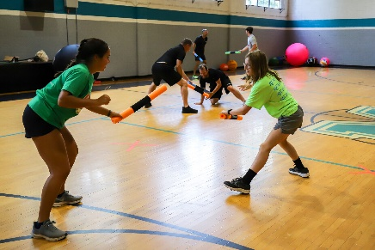
P.S.H.E/R.S.E.  What are you looking forward to in Year 5?  Make a list of ten things that you are looking forward to taking part in after September. | 

