
Year 4 - Home Learning
Summer 1

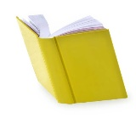
Reading
Children will get the opportunity to visit the library to choose a book to read. Please encourage your child to read a little each day.
Mathematics
MyMaths homework will continue be set, with weekly tasks linked to current topics. As usual, there will be a weekly start and end date for each task set meaning a shorter window of completion.
Also, please ensure that your child is practising their multiplication facts, (times tables) one to twelve, using Times Tables Rock Stars.
English – Arthur and the Golden Rope  Our new focus text which we will be using this half term is ‘Arthur and the Golden Rope’ by Joe Todd-Stanton.  - This is a mythical story.  Have you read another story based on a myth?  Write your own story based on a myth.  - Mythical stories usually feature unusual beings or creatures.  Write a character description of a mythical creature, detailing information about their appearance, personality and other facts such as their age, family and place of origin. | 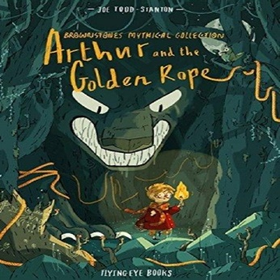
Science – Electricity  What exactly is electricity?  Why is it so important to humans?  List ten things from your house that use electricity to work.  List ten more items that don’t use electricity. | 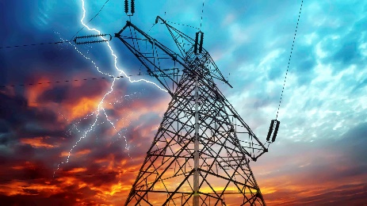
Geography – How do rivers form and what are they used for?  Research a river of your choice.  How did your particular river come into exsistance?  Why is your chosen river important? | 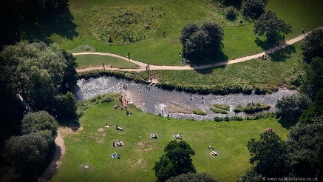
Computing  How quick at you at typing on a computer keyboard?  Can you touch type using all of your fingers?  Why not practice using the program below?  BBC Bitesize: Dance Mat Typing for 7 - 11 year olds. | 
P.S.H.E/R.S.E.  Write a list of ten kind phrases which you can share with your friends at school.  What sort of things do you think people would like to hear?  What positive emotions will your lovely words provoke? | 

