
Year 4 - Home Learning
Spring 2


Reading
Children will get the opportunity to visit the library to choose a book to read. Please encourage your child to read a little each day.
Mathematics
MyMaths homework will continue be set, with weekly tasks linked to current topics. As usual, there will be a weekly start and end date for each task set meaning a shorter window of completion.
Also, please ensure that your child is practising their multiplication facts, (times tables) one to twelve, using Times Tables Rock Stars.
English – Into the Forest  Our new focus text which we will be using this half term is ‘Into the Forest’ by Anthony Browne.  - Have you ever read another book by Anthony Browne? Write a book review of an Anthony Browne book.  - Go and visit a local forest. Write a setting description of the forest. Remember to use noun phrases, similies, adverbs and personification. | 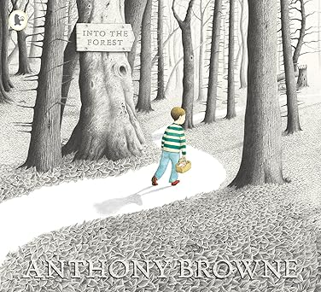
Science – Sound  Sit in a safe place and close your eyes.  Write down all the sounds that you can hear.  Consider, where are the sounds coming from?  How are you hearing them? | 
History – What changed in Britian after the Anglo-Saxon invasion?  Research, who were the Anglo-Saxons?  Why did they come to Britain?  Where did they come from?  Write as many facts as you can about the Anglo-Saxons. | 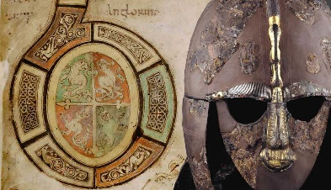
P.S.H.E/R.S.E.  Write ten things which you feel that would make playtimes better with your friends.  Think along the lines of how you treat other people.  For example, use kind words when talking to my friends. | 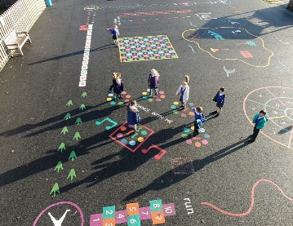
Physcial Education  Try a new sport or game.  This could be with your family, in the park or the garden.  You might go to a leisure centre to try it out.  Write a diary entry about your experience. | 

