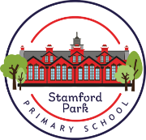
Year 4 - Home Learning
Autumn 2

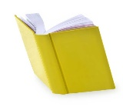
Reading
Children will get the opportunity to visit the library to choose a book to read. Please encourage your child to read a little each day.
Mathematics
MyMaths homework will continue be set, with weekly tasks linked to current topics. As usual, there will be a weekly start and end date for each task set meaning a shorter window of completion.
Also, please ensure that your child is practising their multiplication facts, (times tables) one to twelve, using Times Tables Rock Stars.
English
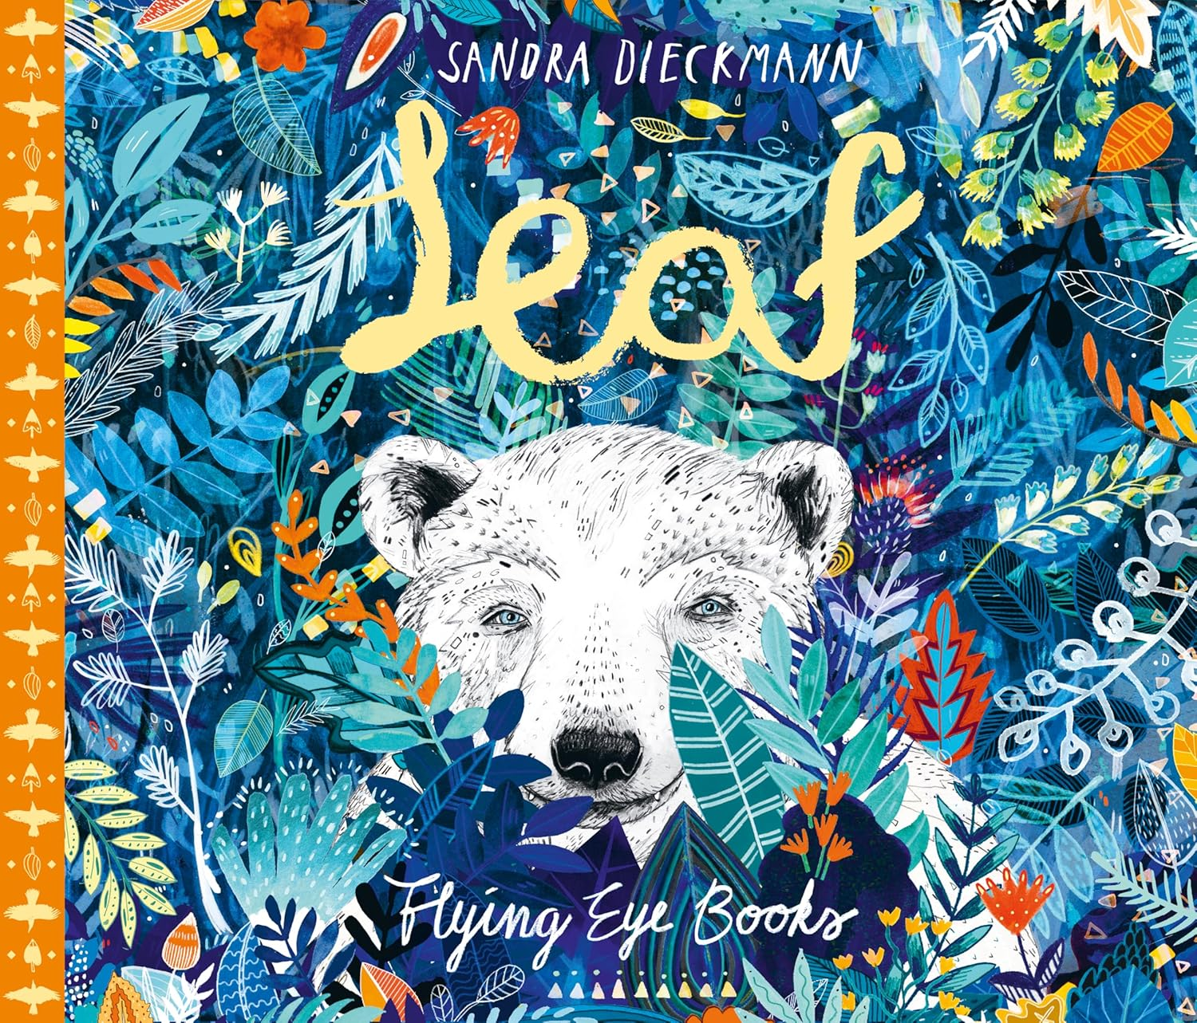
This half term we will read ‘The Leaf’ by Sandra Dieckmann.
Enjoy an ‘Autumn walk’ with an adult.
Describe the walk using adjectives, adverbs smiles and as much descriptive language as you possibly can.
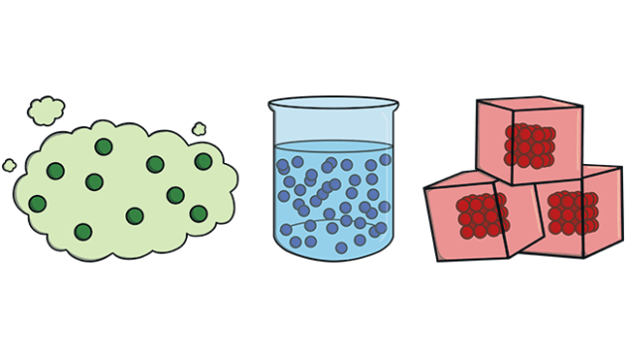
Science – States of Matter
Create a poster to explain what matter is. Try to include the three states of matter along with some examples.

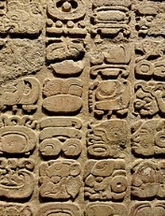
History – How have children’s lives changed over time?
Interview your parents/grandparents about what they did when they were children. You can record this in written form, create a short video or radio recording.
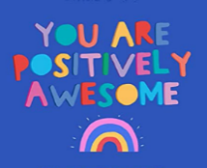
Health and Wellbeing
Understand how to keep our bodies and minds healthy through good choices and habits. Create mind map (pictures and words) of all the things that you do to keep yourself healthy.
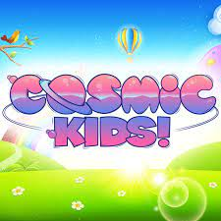
Physcial Education
Complete a yoga workout.
https://www.youtube.com/@CosmicKidsYoga/videos-
See if you can create your own sequence for someone to follow.

