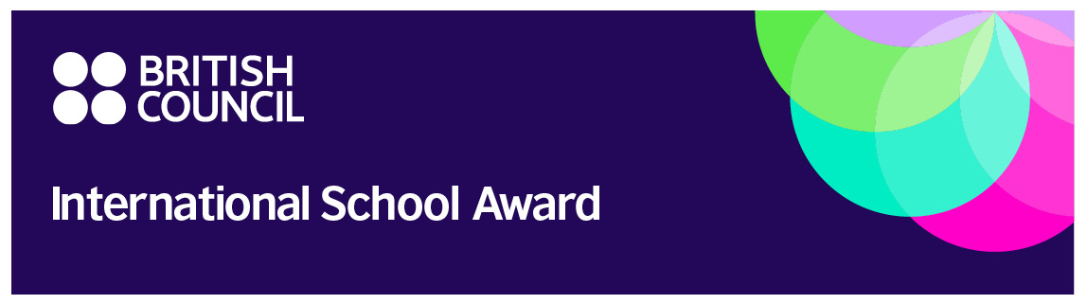
Press release July 2026

British Council International School Award success for
Stamford Park Primary School

Stamford Park Primary School in Hale has been awarded Intermediate level of the British Council’s prestigious International School Award in recognition of its work to bring the world into the classroom.

The International School Award celebrates the achievements of schools that do exceptional work in international education. Fostering an international dimension in the curriculum is at the heart of the British Council’s work with schools so that young people gain the cultural understanding and skills they need for life and work in today’s world.

Stamford Park’s international work includes: pen pals for all of UKS2 in two French schools; video contact with our link Spanish school in Reception; collaborative Digipad work with two other French schools for Year 3, Year 4 and Year 1; a whole-school celebration of the European Day of Languages and no pen day to promote our growing inclusive curriculum!

On hearing the news that Stamford Park Primary School had achieved Intermediate level of the award, Headteacher Mrs Price said: We are incredibly proud to have been awarded the Intermediate Level of the British Council's International School Award. Providing our pupils with opportunities to learn about different cultures, languages and perspectives helps them become confident, curious and respectful global citizens. This recognition celebrates the creativity, enthusiasm and commitment of our staff and pupils in bringing the wider world into our classrooms here.

Shannon West, Head of UK Schools for the British Council, said: Stamford Park’s international work has earned the school well-deserved recognition with the British Council International School Award - Intermediate Certificate.

We are proud and delighted to work with this great school. Many thanks to everyone for all their commitment to developing international work and sharing excellent classroom practice and resources. This is enriching education for its pupils, and their excellent collaborative projects with partner schools overseas are bringing the world into their classrooms. International work is key support for developing skills young people need to be globally aware citizens of the future.

Embedding an international ethos across a school can lead to International School Award Accreditation, the highest award level. Schools looking to join this supportive and engaging global network should contact us at the British Council”.

The Award is now available worldwide in countries such as Greece, India, and Nigeria. Over 6000 International School Awards have been presented to successful schools in the UK since the scheme began in 1999.

The International School Award encourages and supports schools to develop:

- An international ethos embedded throughout the school
- A whole school approach to international work
- Collaborative curriculum-based work with international partner schools
- Year-round international activity
- Involvement of the wider community

To interview the school or for images, please contact mdurrant@spprimary.org.uk

For more information about the International School Award, please get in touch with our team at isa@britishcouncil.org

Notes to Editors:

The British Council International School Award started in 1999 to recognise the schools leading the way in instilling and developing a global dimension into the learning experience of all children and young people. It is managed by the British Council.

About the British Council
The British Council is the UK’s international organisation for cultural relations and educational opportunities. We support peace and prosperity by building connections, understanding and trust between people in the UK and countries worldwide. We do this through our work in arts and culture, education, and the English language. We work with people in over 200 countries and territories and are on the ground in more than 100 countries. In 2022–23 we reached 600 million people.
www.britishcouncil.org

For more information, please visit www.britishcouncil.org. You can also follow the British Council Schools' social media channels www.twitter.com/Schools_British and www.facebook.com/Schools.BritishCouncil

